Student Name: Wenqing Zhao

Student Number: 21211886

**Part 1**

1. **List the MAC Address of PC and laptop nodes**

PC-1 IP: 192.168.1.2 MAC Address: 0030.F2BC.D75B

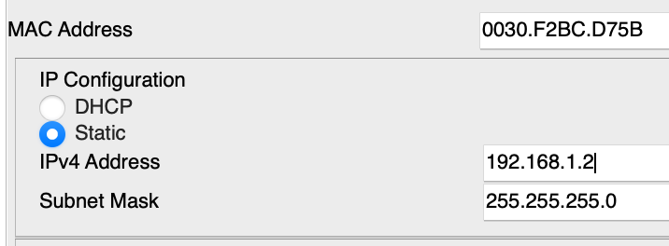

PC-0 IP: 192.168.1.1 MAC Address: 0001.6451.140E

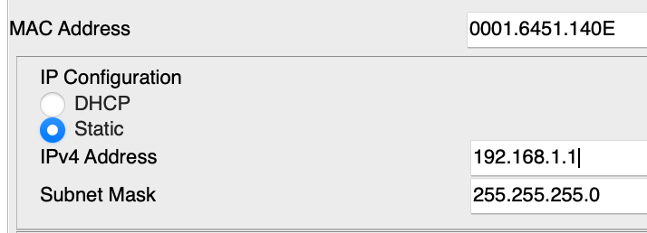

Laptop-1 IP: 192.168.1.3 MAC Address: 000C.CF54.ADB8

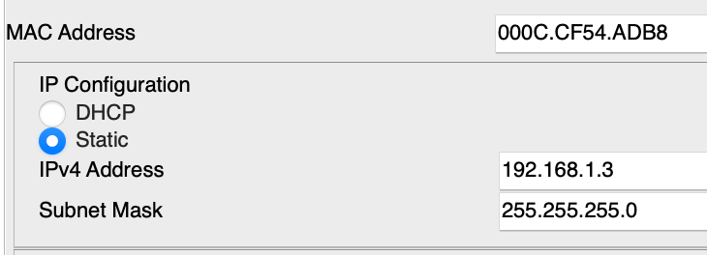

1. **Are the MAC Addresses Unique?**

Yes, they are unique.

1. **Why are they unique/not unique?**

Since MAC addresses are assigned by manufacturers and each manufacturer has a unique identifier, even if two NICs from different manufacturers have the same MAC address, they will not conflict in the same network. Thus, the MAC address is a unique identifier for the device in the network and is used to ensure that packets are sent to the correct device.

1. **Research how MAC Addresses are assigned to devices and summarise in a few sentence here.**

The MAC address is assigned by the manufacturer of the Network Interface Card and recorded into the device hardware, so the device is shipped with a unique MAC address.

**Part 2**

1. **Identify the source and destination mac addresses**

The source address is 0001.6451.140E

The destination address is FFFF.FFFF.FFFF

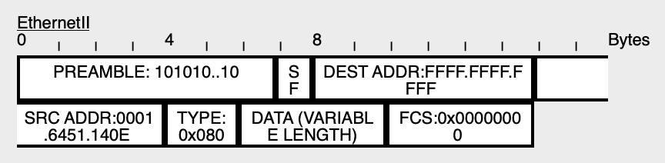

1. **What device (if any) does the destination mac address refer to**

Destination MAC Address refer to every device on the network.

1. **List the addresses that you can identify and what type of address they are.**

source MAC Address: 0001.6451.140E

source IP Address: 192.168.1.1

target IP Address: 192.168.1.2

Both IP Address are IPV4.

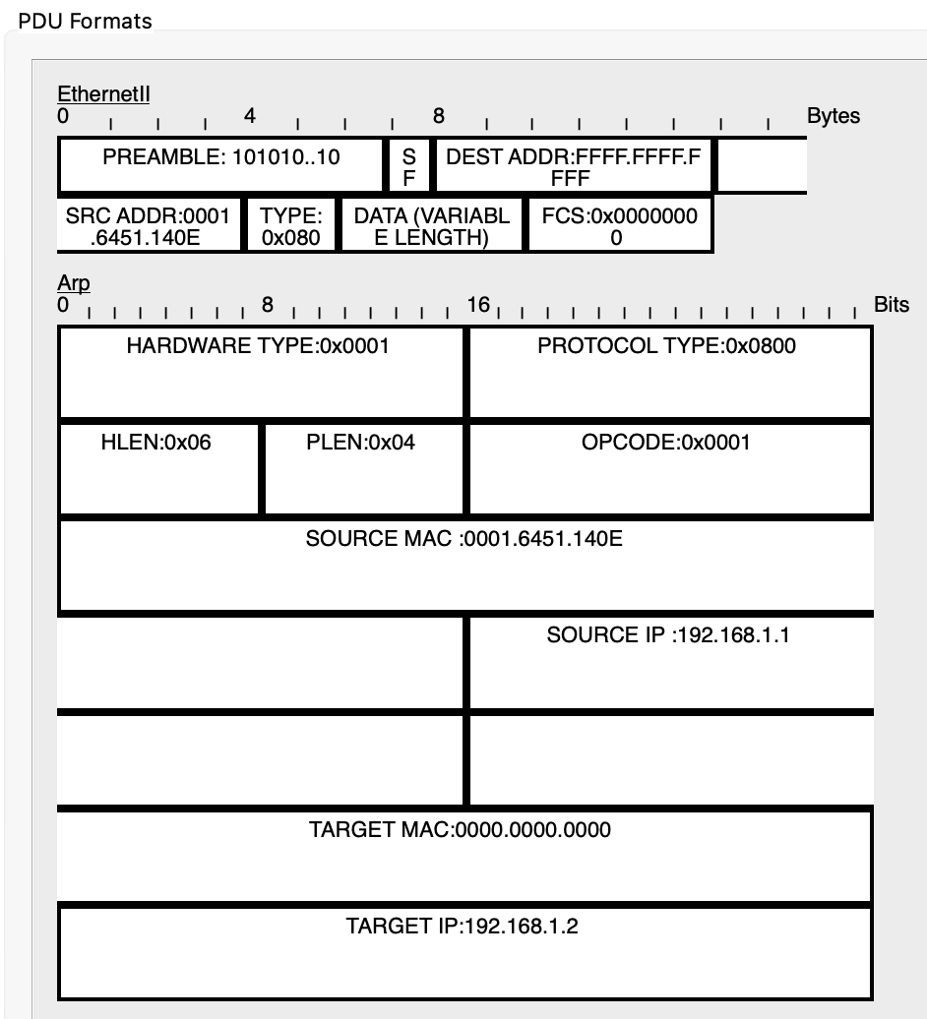

1. **What device does the target IP address correspond to.**

The target IP Address correspond to PC-1 which has IP 192.168.1.2

**Part 3**

1. **Identify the source and destination mac addresses.**

The source MAC Address is 0030.F2BC.D75B

The destination MAC Address is 0001.6451.140E

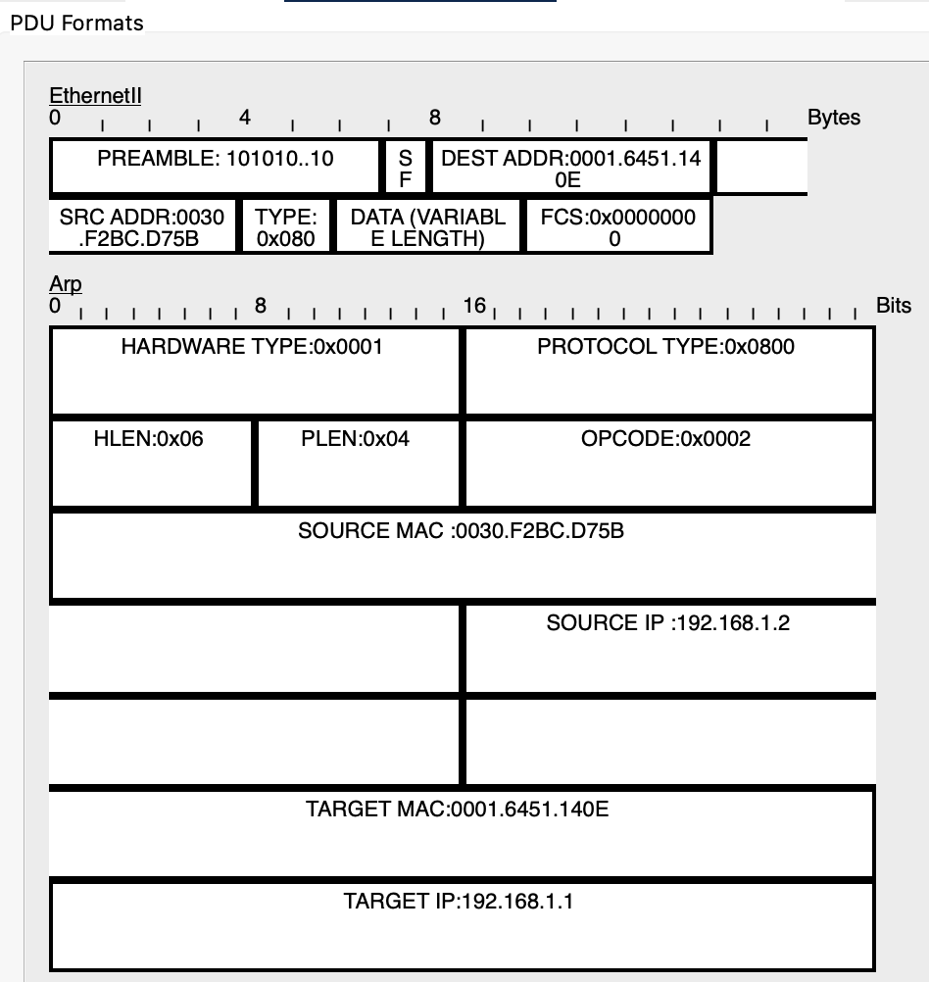

1. **What device does the destination mac address refer to**

The destination MAC Address refer to PC-0 with IP Address 192.168.1.1

1. **List the addresses that you can identify and what type of address they are.**

Source MAC Address: 0030.F2BC.D75B

Target MAC Address: 0001.6451.140E

Source IP Address: 192.168.1.2

Target IP Address: 192.168.1.1

Both IP Address are IPV4.



1. **What device does the Source MAC address correspond to.**

The source MAC Address correspond to PC-1 with IP Address 192.168.1.2

**Part 4**

1. **How many types of arp message are there, and what are they?**

There are two types of arp, which are request arp and reply arp.

1. **What are the 4 address fields of an ARP messages?**

The four address fields include source MAC Address, target MAC Address, source IP Address and target IP Address.

1. **What size (in bits) is each of these fields?**

Source MAC Address and target MAC Address: 48 bits.

Source IP Address and target IP Address: 32 bits.

1. **How do these fields differ between a request and reply ARP message?**

In a request ARP, the target MAC Address is 0000.0000.0000

In a reply ARP, the target MAC Address is precise.

1. **Why is the request ARP message sent to Laptop-1?**

Because it is a broadcast, so the request ARP message should be sent to every device on the network which contains Laptop-1.

1. **What does Laptop-1 do in response to the message?**

Laptop-1 did nothing to respond.

1. **Draw the sequence of ARP messages used to resolve an IP Address to a MAC Address. Indicate if the messages are broadcast or unicast.**
   1. PC-0 send an ARP message to switch with target IP Address. This message is broadcast.
   2. Switch send several ARP messages to every device on the network with target IP Address. This message is broadcast.
   3. PC-1 receive an ARP message and reply an ARP message with the MAC Address to switch. This message is unicast.
   4. Switch send the ARP message to PC-0 with the MAC Address. This message is unicast.